Gerami Academy of Fine Arts
200 Arceneaux Street
Lafayette, La. 70506
(337) 235-6906
e-mail: Rebecca@geramiacademy.com

Dear Parents and Students:
Our Summer schedule will offer the following subjects in one 4-week workshop. If interested, please return this registration form with the required fee by
June 1, 2022. These classes are on a first come, first serve basis only. We do limit the size of our classes. Quoted fees for a full 4-weeks. Please include fees with this form. If using a credit card, please fill out lavender form.

Start Date: Monday, July 18, 2022
EXERCISE
_____Kick & Punch Cardio Exercise: Mon. (6:00-6:45 p.m.) Sat. (9:15-10:00 a.m.) ($80.00)
_____Basic Yoga (50+) – Tues. (6:15-7:00 p.m.) ($50.00)
_____Basic Yoga (50+)– Wednesday & Friday (10:00-10:45 a.m.) ($80.00)
_____Strength/Weights: Tues. (5:30-6:15 p.m.) ($50.00)
_____Flexibility Workout: Wednesday (5:30-6:15 p.m.) ($50.00)

DANCE/TUMBLING
_____Pre-Pointe: (Age 8-up): Tues. (5:30-6:15 p.m.) ($60.00)
_____Pointe I/II: Monday (5:15-6:00 p.m.) ($60.00)
_____Adult Beginner Tap: Mon. (6:30-7:15 p.m.) ($60.00)
_____Couples Ballroom: Wed. (6:15-7:00 p.m. ) ($80.00)
_____Musical Theatre Dance (History/Choreography) Wed. (5:30-6:15 p.m.) ($70.00)
_____Teen & Adult Basic Ballet (Age 12-up) – Tues. (6:15-7:00 p.m.) ($60.00)
_____Teen/Adult Hip Hop Jazz (Age 12-up) – Tues. (5:30-6:15 p.m.) ($60.00)
_____Childrens Ballet/Jazz (Age 7-11) – Tuesday (5:30-6:30 p.m.) ($70.00)
_____Childrens Tumbling (Age 7-12) Monday (5:00-6:00 p.m.) ($70.00)
_____Childrens Tumbling (Age 5-8) Monday (5:00-6:00 p.m.) ($70.00)
_____Pre-School Tap/Ballet/Tumbling (Age 3-5) – Monday (1:30-3:00 p.m.) ($80.00)
_____Pre-School Tap/Ballet/Tumbling (Age 3-5) – Tuesday (10:00-11:30 a.m.) ($80.00)
_____Pre-School Tap/Ballet/Tumbling (Age 3-5) – Monday (5:00-6:30 p.m.) ($80.00)
_____Pre-School Tap/Ballet/Tumbling (Age 3-5) – Wednesday (1:30-3:00 p.m.) ($80.00)
_____Pre-School Tap/Ballet/Tumbling (Age 3-5) – Thursday (9:45-11:15 a.m.) ($80.00)
_____Primary/Adv. Primary Tap/Ballet/Tumbling (Age 5-6) – Tues (4:00-5:30 p.m. ($80.00)
_____Int./Adv. Tumbling (All ages) – Wednesday (5:00-6:00 p.m.) ($70.00)
_____Int./Adv. Jazz (All ages) – Wednesday (5:15-6:15 p.m.) ($70.00)
_____Int./Adv. Ballet (All ages) – Monday (6:00-7:00 p.m. ($70.00)

STUDENTS NAME:_____________________________BIRTHDATE:___/___/________
PARENTS NAME IF MINOR:________________________________________________
MAILING ADDRESS:_______________________________________________________
CITY:________________________________ZIP CODE:___________________________
E-MAIL: (Please print)_______________________________________________________
TELEPHONE: (Home)_________________(Office)______________(Cell)____________
HOW MANY YEARS OF INSTRUCTION IN THE COURSE(S) CHECKED_________

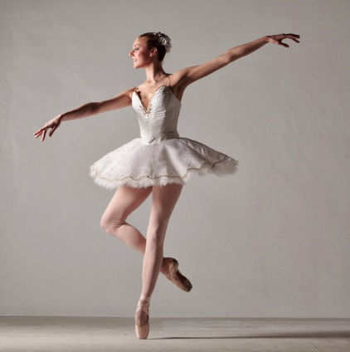

SUMMER BALLET INTENSIVE

Our Summer Ballet Intensive is for those students that want to be inspired, challenged, and have the opportunity to experience a solid dedication to Ballet. It will be offered to students with previous ballet training for ages 10-up. Ability level is Intermediate.
Students will take 4 weekly classes of Ballet offered in two week workshops. Student may take all of the two week courses or pick and
choose certain dates. Please include fees with this form.

______WORKSHOP I – JULY 8 THRU JULY 20, 2019 ($150.00)
______WORKSHOP II – JULY 22 THRU AUGUST 3, 2019 ($150.00)
______WORKSHOP III – AUG. 5 THRU AUGUST 17, 2019 ($150.00)

CLASS TIMES OF EACH WORKSHOP:

Monday 4:00-5:30 p.m.
Wednesday 4:00-5:30 p.m.
Thursday 4:00-5:30 p.m.
Saturday 10:00-11:30 a.m.

CLASS SIZE IS LIMITED.
PLEASE REGISTER BY
MAY 1, 2019.

